|  |  |
| --- | --- |
| Digital Synth |  |
| sam segers |

19-6-2022

Sam Segers

Digital Synth

sam segers

Digitale synthesizer implemented on FPGA De1-SoC.

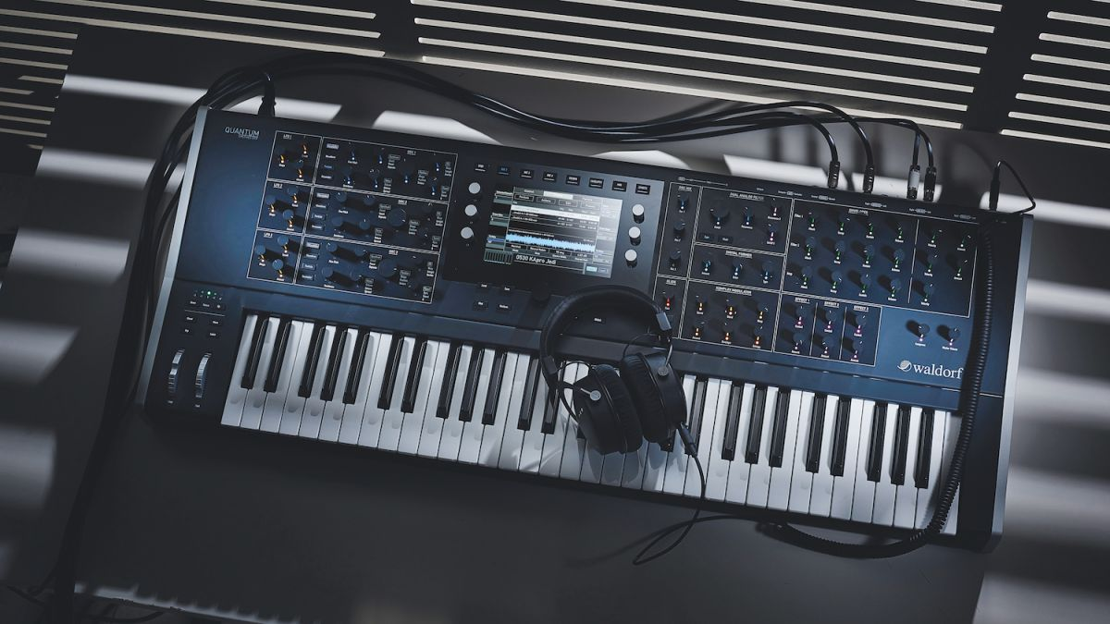

Sam Segers

[Geef de functie van de afzender op]

Digital Synth

# Summary

During the third semester of the Electrical Engineering course, Sam worked on a project related to "sound." The project involved creating a synthesizer on the FPGA De1-Soc platform. This synthesizer is capable of generating four different sound types: sine, square wave, triangle, and sawtooth.

The synthesizer also includes a "sequence" function that allows users to create musical note patterns. Additionally, Sam added some audio effects like a compressor, delay, and phaser to modify the sound output.

Originally, Sam had plans to connect the synthesizer to a MIDI keyboard, allowing it to be played with external keyboards. However, due to time constraints, we couldn't complete this feature.

Contents

Summary 2

Soundwaves 4

Sequencer 5

# Soundwaves

The sound waves are created by sending values ​​to the output at the speed set by a clock divider. The values ​​represent the amplitude with the highest value 255 so that it corresponds to an 8 bit number. This way, every sound wave can be made if you enter the correct values ​​in the code. Using the formula $\frac{clock}{frequentie}=sample rate$, the specific frequency can be created with an associated array size.



Figuur 1 Sine wave code

Because the amplitudes of the sound wave are now only 8 bit numbers, a speaker cannot yet recognize them. For this problem you use a DAC. Shown in figure 2 is a resistance ladder, which is constructed in such a way that the LSB has to bridge through the most resistances to get to the speaker, the MSB the least. Because each output of the FPGA sends out 3.3 volts. This ensures that the speaker receives an analog signal.

Figuur 2 Weerstand ladder

The sound waves were measured with a scope of the Analog Discovery(oscilloscope). Seen in Figure 3.

Figuur 3 Scope meting

# Sequencer

The “secuence” function is a bit-shifter. The notes are switched after a number of clock cycles, these time slots manipulated to a BPM rate so that the instrument becomes playable with external instruments that function with a clock.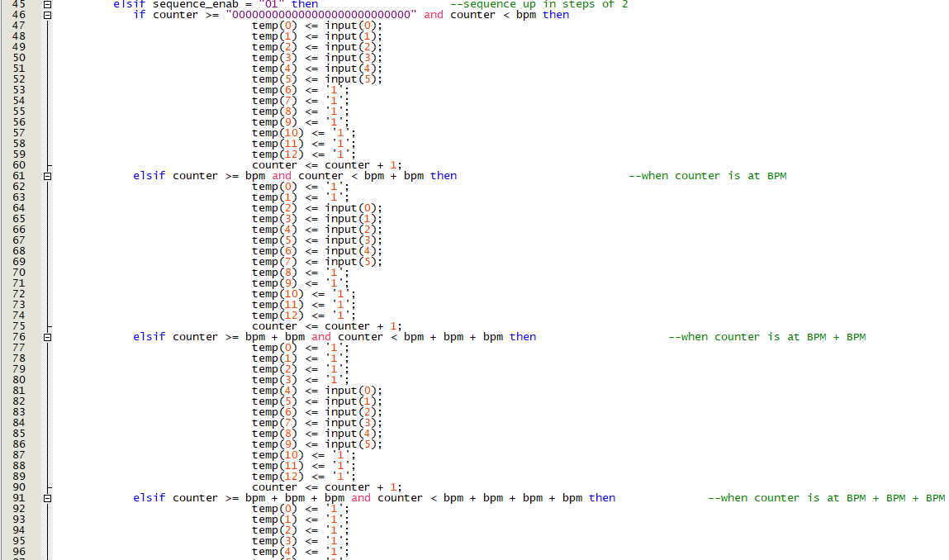

Figuur 4 Sequencer code

The BPM can be changed so that the speed of the sequencer can be changed by the user.

Figuur BPM